1. Registration Code:

package project;

import java.util.Scanner;

public class Registration1 {

private static Scanner sc;

private static String name;

private static String password;

private static String account;

public static void main(String[] args) {

sc = new Scanner(System.in);

System.out.println("Please Select Your Account For Which Ur Trying To Register - facebook/twitter/linkedin : ");

setAccount(sc.nextLine());

System.out.println("Enter Username : ");

setName(sc.nextLine());

System.out.println("Enter Password : ");

setPassword(sc.nextLine());

System.out.println("New User Created");

}

public static String getName() {

return name;

}

public static void setName(String name) {

Registration1.name = name;

}

public static String getPassword() {

return password;

}

public static void setPassword(String password) {

Registration1.password = password;

}

public static String getAccount() {

return account;

}

public static void setAccount(String account) {

Registration1.account = account;

}

}

>>>> Output:

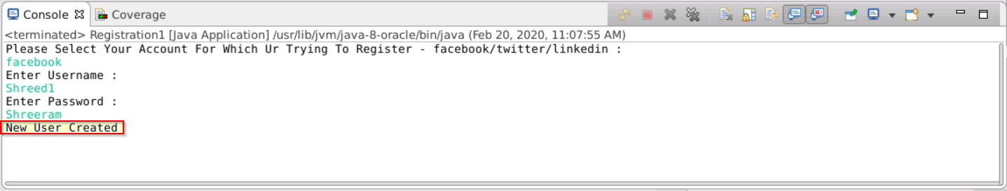

1. Login Code:

package project;

import java.util.Scanner;

public class LoginToAccount {

private static Scanner sc;

private static Scanner input1;

private static Scanner input2;

private static String account;

public static void main(String[] args) {

sc = new Scanner(System.in);

String Username;

String Password;

Username = "wisdom";

Password = "123";

System.out.println("Enter The Account For Which Ur Trying To Login - facebook/twitter/linkedin : ");

setAccount(sc.nextLine());

input1 = new Scanner(System.in);

System.out.println("Enter Username : ");

String username = input1.next();

input2 = new Scanner(System.in);

System.out.println("Enter Password : ");

String password = input2.next();

if (username.equals(Username) && password.equals(Password)) {

System.out.println("Access Granted! Welcome!");

}

else if (username.equals(Username)) {

System.out.println("Invalid Password!");

} else if (password.equals(Password)) {

System.out.println("Invalid Username!");

} else {

System.out.println("Invalid Username & Password!");

}}

public static String getAccount() {

return account;

}

public static void setAccount(String account) {

LoginToAccount.account = account;

}}

>>>> Output:

